**ABESEC Ghaziabad**  

**Department of Computer Science & Engineering**

**SYNOPSIS REPORT**

**(Session 2023-24)**

|  |  |  |  |  |
| --- | --- | --- | --- | --- |
| **Project Title:** Student dropout analysis for school education | | | | |
| **Project Type**(Application, research, review etc.) | |  | | |
|  | **Name** | **Roll Number** | **Section** | **Signature** |
| **Group member (1)** | **Nishant Kumar** | **2100320100112** | **B** |  |
| **Group member (2)** | **Naman Zadoo** | **2100320100109** | **B** |  |
| **Group member (3)** | **Rohit Sharma** | **2100320100133** | **B** |  |
| **Project Guide** | **Ms. Prabhjot Kaur** | **Remarks:** | | |
| **Signature** |  |
| **Date of submission** |  |

**1.1. Problem Introduction**

* + 1. **Motivation**

The issue of student dropout in school education is a critical concern that has far-reaching consequences for both individuals and society as a whole. Understanding and addressing the factors that contribute to student dropout is essential for ensuring equitable and quality education. This problem statement seeks to provide a comprehensive description of the problem of student dropout in school education and the need for analysis and intervention.

**1.1.2** **Project Objective**

The primary objective of conducting a student dropout analysis in the school education system in India is to comprehensively understand the factors, patterns, and root causes contributing to student dropouts. This analysis aims to inform policy, interventions, and strategies that can effectively reduce dropout rates and improve the overall quality and inclusivity of education in the country. Promote equitable and inclusive educational opportunities for all students. By addressing this problem, we can work toward a brighter and more equitable future for students and society as a whole.

**1.1.3** **Scope of the Project**

This project will help government. If government have drop out student analysis on different categories, it will be very useful in framing different policies. The scope for student dropout analysis in Indian school education is comprehensive, aiming to provide a holistic understanding of the problem and to generate evidence-based strategies for reducing dropout rates and improving the overall quality and inclusivity of education in the country.

**1.2. Related Previous Work**

In paper [1], we understand the differential and factors associated with school dropout in India. Dataset: data from national family health survey-3. Found that 75% child age group

6 to 16 were attended school, 14% child never attend, 11% child for various reasons like

Parent illiterate, Parent not working, etc. and Dropout high in caste like Muslims, SC & ST. Major factors are poor quality of schooling/education, high teacher vacancies, Inadequate school infrastructure, father level education is significantly related to drop behavior, poverty is one main cause of drop, house-old and social factor. Conclusion: Gender differentials were persisting in school negligible in urban area, parental characteristic, parent are unemployed, no. of children in family, not interested in study.

In paper [2], the study examines the determinants of school dropouts in India using a survival analysis approach. It finds that factors such as caste division, wealth quintile, type of institution, and regional differences play a significant role in determining school dropouts. The study also identifies reasons for dropout, including lack of interest in education, financial constraints, engagement in domestic or economic activities, distance from school, and inability to cope up or failure in studies. The study recommends improving school infrastructure and the quality of education, as well as implementing programs to prevent early marriage among females, in order to reduce school dropout rates in India.

The insight we get from paper [3], Educational Data Mining (EDM) is a crucial application of data mining that helps in predicting educational dropout and providing timely help to students. However, EDM has not been introduced at higher education level in India. The objective of this analysis is to find the existing gaps in predicting educational dropout and identify the missing attributes that can contribute to better prediction. The study also aims to find the best attributes and data mining techniques frequently used for dropout prediction. The literature review reveals that factors such as student grades, gender, family structure, parents' qualification and occupation, household responsibilities, addictions, basic facility in educational institutions, poor teaching methodology, and getting married can significantly affect educational dropout. Data mining techniques such as logistic regression analysis, CART, C4.5, J48, SL, JRip, RF, Naïve Bayesian Algorithm, and association rules mining are commonly used for predicting dropout.

In paper [4], we learn that the dropout ratio in 2018-19 for secondary level classes IX and X is 17% as compared to 4% in primary classes I to V. To minimize the dropout ratio, the technique of prediction is proposed, the most widely used in K-nearest neighbor. In human resource development, education plays an important role. Dataset is gathered by initiated a web-based all India survey on higher education (AISHE) and collect data such as student enrollment, teacher, progress, gross enrollment ratio, etc. dropout causes: domestic activities, marriage and lock of interest are the main reason for female while lack of interest, economic activities are for male. The main goal for this study is to predict weather the student should go for dropout or not. Conclusion: with the help of prediction, the teacher focus on feature of a student and counsel student who are at risk, and early step will benefit the student to overcome their studies.

In paper [5], the authors discuss the issue of school dropout rates in India and highlight the importance of education for the progress of a nation. They analyze the trends in dropout rates at the secondary stage in different regions of India and identify the major causes for student dropout, such as child marriage, lack of transportation and facilities, safety and security concerns, parental education, and lack of interest in school. The authors also provide policy implications and suggestions for reducing dropout rates, including improving school culture, providing basic facilities, implementing teacher training programs, and conducting remedial teaching programs.

Paper [6], discusses the use of predictive modeling in educational data mining to identify student dropout indicators. The authors propose an improved decision tree algorithm that takes into account socio-demographic, academic, and institutional data to predict whether students will continue or drop out of their studies. The algorithm uses Renyi entropy information gain and association function to improve the accuracy of the predictions. Experimental results show that the improved decision tree algorithm outperforms traditional classification algorithms in terms of prediction accuracy. The paper also provides insights into the factors that contribute to student dropout, such as family problems, homesickness, campus environment, and low placement rates. University administrators to create guidelines and policies to reduce student dropout and increase enrollment rates can use the proposed algorithm.

**1.3 Software and Hardware requirements**

**Software used**:

1. **Python**

Python is a high-level, general-purpose programming language. Its design philosophy emphasizes code readability with the use of significant indentation. Python is dynamically-typed and garbage-collected. It supports multiple programming paradigms, including structured, object-oriented and functional programming

2) **HTML**

HTML is a type of markup language. It encapsulates, or “marks up” data within HTML tags, which define the data and describe its purpose on the webpage.

3) **CSS**

Cascading Style Sheets is a style sheet language used for describing the presentation of a document written in a markup language such as HTML or XML. CSS is a cornerstone technology of the World Wide Web, alongside HTML and JavaScript.

4) **JAVA Script**

JavaScript, often abbreviated to JS, is a programming language that is one of the core technologies of the World Wide Web, alongside HTML and CSS

**Hardware used**:

1. **Memory**

Computer memory is the storage space in the computer, where data is to be processed and instructions required for processing are stored. The memory is divided into large number of small parts called cells. Each location or cell has a unique address, which varies from zero to memory size minus one.

2) **RAM**

RAM is a temporary memory bank where your computer stores data it needs to retrieve quickly. RAM keeps data easily accessible so your processor can quickly find it without having to go into long-term storage to complete immediate processing tasks.

3) **CPU**

A central processing unit (CPU), also called a central processor, main processor or just processor, is the electronic circuitry that executes instructions comprising a computer program.

**1.4 Proposed Method**

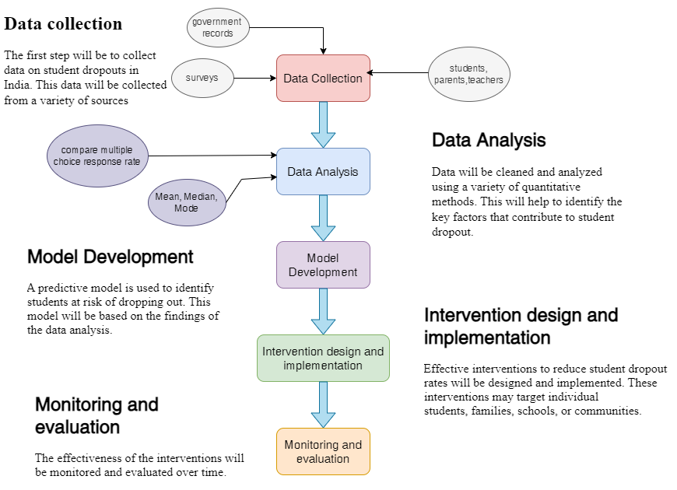

**1.5 Deliverables**

This project is helpful for government for framing new polices or policy development and Data-driven insights can influence education policy at local, regional, and national levels to promote inclusive and equitable education.

**1.6 Stakeholders**

Our project would be very helpful for government officials at the central and state levels, along with educational policymakers, have a stake in understanding and mitigating the issue of student dropouts to improve the quality and reach of education in India.

**1.7 References**

[1].Sateesh Gouda M, Dr.T.V Sekher: Factor Leadind to School Dropout in India: An Analysis of National Family Health Survey-3 Data.

[2].Mausam Kumar Garg, Poulomi Chowdhury, Illias Sheikh: Determinats of school dropouts in India: a study trough survival analysis approach.

[3].Mukesh Kumar, Prof. A.J. Singh, Dr. Disha Handa: Literature Survey on Educational Dropout Predition.

[4].Mahesh Mardolkar, N.Kumaran,: Forecasting and Avoiding Student Dropout Using the K-Nearest Neighbor Approach.

[5].Dr.K.V.sridevi, Mohini Nagpal: Trends in School Dropout Rate in India.

[6].Subitha Sivakumar, Sivakumar Venkataraman, Rajalashmi Selvaraj: Predictive Modelling of Student Dropout Indicators in Educational Data Mining using Improved Decision Tree.